# 1 Issue 0020539:

* 1. Test Report

D-0020539: <EVT FW BB CPLD> DRIVE_xx_PWROK register couldn't reflect Drv[x]_PWR_EN_L signal state.

3/26/2015, BB CPLD V01.09:

1) Default value is FF 0F 00 00 00 which should be all 00 as design spec defined.

2) When DRIV_x_PWR_EN register is 1b and SAS HDD is inserted, the corresponding DRIVE_x_PWROK returns 0b which should be 1b to reflect the low active signal is asserted.

5/23/2015, BB CPLD V02.02 duyu

1. PCIE SSD’s POWER_OK can be read correctly from 31h[7:4],32h,33h,34h[3:0]
2. SAS SSD’s POWER_OK is always as ‘0b’
   1. Root cause

PCIE SSD can output POWER_OK, but SAS HDD cannot output right POWER_OK, it is always “0b”

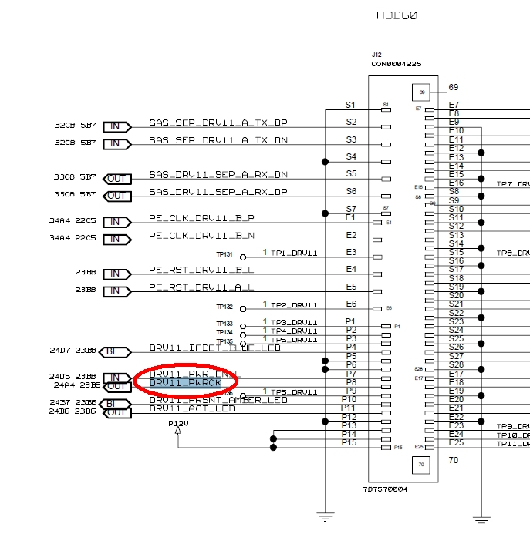

* 1. Solution

We can detect DRV*_IFDET_BLUE_LED and DRV*_PRSNT_AMBER_LED to check which type HDD inserted, PCIE SSD or SAS HDD.

1. If PCIE SSD has been inserted, then we use real POWER_OK signal for power ok register --- 31h[7:4]~34h
2. If SAS HDD has been inserted, then we use power enable for 31h[7:4]~34h
3. Always use power enable register value for 30h~31h[3:0]

The real hardware signal as below,

1. The slot which can support both PCIE and SAS, test at Slot HDD56:

|  |  |  |
| --- | --- | --- |
| HDD Type | DRV*_IFDET_BLUE_LED | DRV*_PRSNT_AMBER_LED |
| PCIE SSD | 0.28v | 3.25v |
| SAS HDD | 0.28v | 0.28v |
| N/A | 3.25v | 3.25v |

1. The slot which only can support SAS, test at HDD6

|  |  |  |
| --- | --- | --- |
| HDD Type | DRV*_IFDET_BLUE_LED | DRV*_PRSNT_AMBER_LED |
| SAS HDD | 0.3v | 0.3v |
| N/A | 3.25v | 3.25v |

|  |  |
| --- | --- |
| Hudson Comments |  |
| QA Comments |  |

* 1. New BB CPLD version

I will release 02.03 to fix this issue, please QA team help verify, thanks.

# Issue 0020586

2.1 Test Report

D-0020586 Priority 3-Normal

Title <EVT FW BB CPLD> Register A0h hasn't control SGPIO outputs enbale or disable.

On Fri, Mar 20, 2015 at 3:50 AM EDT, Sharron Yang wrote:

3/20/2015, V0107:

A0 could control SPGIO, but when system power on, all 72 Drive Activity LEDs are solid on, even no HDD is inserted.

5/23/2015, BB CPLD V02.02 and SSM CPLD V01.06 duyu

SAS HDD LED can blink and ON, the function is ok.

PCIE can not blink, because it can not active under OS.

* 1. Duyu’s comments

CPLD use the same DRV*_ACT_LED signal for PCIE SSD and SAS HDD, so, if SAS HDD’s LED can work well, The PCIE SSD should be OK. I also verify latest CPLD on David’s test bench, the PCIE LED can be lighted. Please refer to below picture. So, I suggest that we can close this issue on saleforces. Please help verify, thanks.

